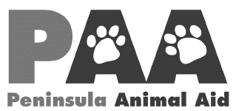

P.O. Box 163, Margate. Qld.4019
313 Duffield Road, Clontarf. Qld
Phone: 07 3284 1927 Fax: 07 3284 5902
www.peninsulaanimalaid.com.au
Email: paa@peninsulaanimalaid.com.au
ABN: 54 720 195 065

APPLICATION FOR MEMBERSHIP RENEWAL

Surname: |  | First Name:
Street Address:
Suburb: |  | Postcode:
Home Phone: |  | Mobile Phone:
Email:

Please tick your preferred method of communication by correspondence:
To my email address above. I give my express permission for PAA to contact me by email.
To my postal address as shown above.

Please tick the appropriate box(s):
 | Please find enclosed my membership fee of | $10.00
 | Please find enclosed my donation of | $
 | TOTAL | $

Signed: _____________________________________________ Date: ____________________

Post To: Or drop into the shelter at:
PENINSULA ANIMAL AID 313 Duffield Road
PO Box 163 Clontarf
Margate Q 4019

Any enquiries please call 07 3284 1927.
Your membership renewal is subject to approval by the Management Committee.
All members must comply with PAA’s Code of Conduct for Members.

